A Location Analysis for Future Commercial and Industrial Development in San Marcos, TX
Philip Ramirez
Project Manager
Paul Daugherty
Assistant Manager/GIS Analyst
Jared Reid
Webmaster/GIS Analyst
Jeff Ivy
GIS Analyst

Table of Contents Page

1. Introduction. . . . . . . . . . . . . . . . . . . . . . . . . . . . . . . . . . . . . . . . . . . . . . . . . . . . . . . . . . . . . . . . . .2

1.1 Purpose. . . . . . . . . . . . . . . . . . . . . . . . . . . . . . . . . . . . . . . . . . . . . . . . . . . . . . . . . . . . .2

1.2 Problem Statement. . . . . . . . . . . . . . . . . . . . . . . . . . . . . . . . . . . . . . . . . . . . . . . . . .2

1.3 Scope. . . . . . . . . . . . . . . . . . . . . . . . . . . . . . . . . . . . . . . . . . . . . . . . . . . . . . . . . . . . . . . 2

2.0 Literature Review. . . . . . . . . . . . . . . . . . . . . . . . . . . . . . . . . . . . . . . . . . . . . . . . . . . . . . . . . . . 3

2.1 Article 1. . . . . . . . . . . . . . . . . . . . . . . . . . . . . . . . . . . . . . . . . . . . . . . . . . . . . . . . . . . . .3

2.2 Article 2. . . . . . . . . . . . . . . . . . . . . . . . . . . . . . . . . . . . . . . . . . . . . . . . . . . . . . . . . . . . .3

3.0 Data. . . . . . . . . . . . . . . . . . . . . . . . . . . . . . . . . . . . . . . . . . . . . . . . . . . . . . . . . . . . . . . . . . . . . . . . 4

4.0 Methods. . . . . . . . . . . . . . . . . . . . . . . . . . . . . . . . . . . . . . . . . . . . . . . . . . . . . . . . . . . . . . . . . . . . .5

4.1 Macro Analysis Process Overview. . . . . . . . . . . . . . . . . . . . . . . . . . . . . . . . . . . . 5

4.2 Vector to Raster Conversion . . . . . . . . . . . . . . . . . . . . . . . . . . . . . . . . . . . . . . . . . 6

4.3 Reclassifying the Layers . . . . . . . . . . . . . . . . . . . . . . . . . . . . . . . . . . . . . . . . . . . . 7

4.4 The Weighted Overlay . . . . . . . . . . . . . . . . . . . . . . . . . . . . . . . . . . . . . . . . . . . . . . 8

4.5 Micro Analysis Overview . . . . . . . . . . . . . . . . . . . . . . . . . . . . . . . . . . . . . . . . . . . .9

5.0 Results . . . . . . . . . . . . . . . . . . . . . . . . . . . . . . . . . . . . . . . . . . . . . . . . . . . . . . . . . . . . . . . . . . . . . 9

5.1 Macro Analysis Results. . . . . . . . . . . . . . . . . . . . . . . . . . . . . . . . . . . . . . . . . . . . . . 9

5.2 Micro Analysis Results . . . . . . . . . . . . . . . . . . . . . . . . . . . . . . . . . . . . . . . . . . . . . . 10

6.0 Discussion . . . . . . . . . . . . . . . . . . . . . . . . . . . . . . . . . . . . . . . . . . . . . . . . . . . . . . . . . . . . . . . . . 12

6.1 Data Quality . . . . . . . . . . . . . . . . . . . . . . . . . . . . . . . . . . . . . . . . . . . . . . . . . . . . . . . 12

6.2 Data Processing . . . . . . . . . . . . . . . . . . . . . . . . . . . . . . . . . . . . . . . . . . . . . . . . . . . . 12

6.3 Comprehensive Design. . . . . . . . . . . . . . . . . . . . . . . . . . . . . . . . . . . . . . . . . . . . . . 13

6.4 Final Deliverables . . . . . . . . . . . . . . . . . . . . . . . . . . . . . . . . . . . . . . . . . . . . . . . . . . 14

6.5Pros/Cons of using GIS. . . . . . . . . . . . . . . . . . . . . . . . . . . . . . . . . . . . . . . . . . . . . . 15

Appendix 1.0 Maps . . . . . . . . . . . . . . . . . . . . . . . . . . . . . . . . . . . . . . . . . . . . . . . . . . . . . . . . . . . . 15

Appendix 2.0 Data Dictionary/ Metadata . . . . . . . . . . . . . . . . . . . . . . . . . . . . . . . . . . . . . . . 19

Appendix 3.0 Contribution of Team Member. . . . . . . . . . . . . . . . . . . . . . . . . . . . . . . . . . . . .31

1.0 Introduction
1.1 Purpose
With the area’s population expected to nearly double by the year 2020, the Austin-San Antonio Corridor can expect to see significant growth not just in population, but also large growth in new housing development, roads, infrastructure, and certainly public facilities such as schools and hospitals. One can also expect that the arrival of all these new residents will also mean an increase in consumption of goods and services. It is important to understand there will be a large push towards further economic development in this region. The city of San Marcos is located halfway between Austin and San Antonio, and is in a prime position to take advantage of the expected trend in regional economic growth. However, the problem with achieving such development is that there are numerous factors that must be considered in location analysis for sites suitable for economic development, both quantitative and qualitative. Any new commercial or industrial development must be strategically located to optimize many of the variables associated with this development while considering things such as, transportation accessibility, infrastructure availability, environmental impact concerns, future land usage and possible community residential impacts.
1.2 Problem Statement
The main objective of this study was to identify at least 10 parcels of land in close proximity or within the city limits of San Marcos that meet the minimum acreage requirement of 15 acres, and would be most suitable for large industrial or commercial businesses to be developed in the city.
1.3 Scope
The geographic scope of this project will be contained within the city limits of San Marcos, as well as any areas in the ETJ that are adjacent to the city limits, and thus more easily annexed. There is no defined time frame related to this study, other than knowing that the parcels we select could be intended for development sometime in the future, and thus we would need to consider the future of the San Marcos area in general.
2.0 Literature Review
2.1 Levy, J. 2006. Contemporary Urban Planning. p. 352 New Jersey: Prentice Hall.
Central Texas Consulting applied a Middle– Range Model to establish the process of selecting and analyzing the parcels within the defined scope. The Middle- Range Model is a two step process used to narrow broad variables to be further analyzed in the second step of the process. Our plan of action begins with a Macro Analysis which resembles the first process of the Middle-Range Model. This process narrows the selection which becomes the focal point of the Micro Analysis. The Micro Analysis is the corresponding second process of the Middle-Range model which takes a closer observation of the focused areas of interest.
2.2 Malczewski, J. 1999. GIS and Multicriteria Decision Analysis. “GIS and Decision Support” p.78 New York: John Wiley & Sons, Inc.
This subjective(soft) decision making process is necessary along with objective(hard) decisions to provide a comprehensive site by site analysis that supports the objective at hand. Malczewski explains the reality of the decision making processes in conjunction with GIS data capabilities. […the ultimate success of GIS in decision making depends on how well the system can succeed as a spatial decision support system (SDSS) in being incorporated in the decision-making process.] The Micro Analysis acts as a subjective (soft) decision making process that supports the (hard) objective decision making process of the suitability map. The Micro Analysis report verifies the results of the Macro Analysis, which performs as the spatial decision support system, with qualitative and quantitative information for parcel. This added information can then be used by the city as a supplemental resource for selecting parcels for economic development.

3.0 Data
The data needed for making an informative parcel selection was divided into three categories including, infrastructure, physical features, and boundaries. All data was set to coordinate system NAD83 and were projected to State_Plane_South_Central4204. The following list shows all data used in the Macro and Micro Analysis.
Infrastructure
- Transmission Lines
Source: Joan Hickey from the city of San Marcos
LCRA (Pedernales Electric)
Bluebonnet Electric

- Water Main
Source: Joan Hickey from the city of San Marcos

- Waste Water Interceptors
Source: Joan Hickey from the city of San Marcos

- Roads
Source: Joan Hickey from the city of San Marcos

- Road Network Layer
Source: ESRI

- Buildings
Source: Joan Hickey from the city of San Marcos

Physical Features
- Floodplains
Source: Joan Hickey from the city of San Marcos

- DEM (Digital Elevation Model)
Source: USGS’s Seamless Server

- Contours
Source: Capital Area Metropolitan Planning Organization’s (CAPCOG)

- Aquifer
Source: Joan Hickey from the city of San Marcos

Boundaries

- City Limit
Source: Joan Hickey from the city of San Marcos

- ETJ Boundary
Source: Joan Hickey from the city of San Marcos

- Parcel Layer
Source: Joan Hickey from the city of San Marcos

- Vacant Parcels
Source: Capital Area Metropolitan Planning Organization’s (CAPCOG)

- Zoning
Source: Joan Hickey from the city of San Marcos

- Future land use
Source: Joan Hickey from the city of San Marcos

4.0 Methods
Through a group consensus, we determined that the best way to identify ten suitable sites for large commercial or industrial development was to divide the task into two scales of analysis. These two divisions of analysis are referred to as macro and micro level. The macro level is a large scale analysis of San Marcos and its extraterritorial jurisdiction that identifies ten sites through a suitability map. The micro level is a small scale analysis that takes a close look at each property, and provides information that would be helpful to a business that is interested in developing the property. This information is detailed in an extensive report of each site.
4.1 Macro Analysis Process Overview
We located the suitable sites for our project by performing a weighted overlay. We then eliminated land that was determined unusable because it was either encompassed by the FEMA 100 year floodplain, occupied property, or above the Edwards Aquifer. The overlay process adds layers of data together based on a common numerical range that we assigned to each layer. The areas that have the highest sums are the most suitable. The layers that we overlaid consisted of the distance from the major highways, the distance from the city’s water mains, the distance from the city’s wastewater interceptors, the distance from three phase transmission lines, and the slope of the land. This set of data is the infrastructure that is necessary for this type of development. Some of these layers were more important than others. Therefore, we multiplied the layers that we deemed more important by a higher percentage to give them more weight in the overlay. This approach and process is called a “weighted” overlay. However, before we could perform the weighted overlay we had to process and format the data to ensure an accurate analysis.
4.2 Vector to Raster Conversion
The weighted overlay calculations require all layers to be in a raster data model. During the creation of these layers, it was very important that we assigned all the raster layers the same cell size to maintain consistency in the map scale. We defined the new raster layer’s cell size to represent 95.34203133 feet in scale. All the data files that we obtained except for the DEM, the source of the cell size, were in vector format. Therefore, it was mandatory that we converted the data into raster files, and convert the DEM into slope. The data conversions were possible through the Spatial Analyst tools.
For the first conversion, we utilized the convert function, specifically vector to raster. We used this function for the vacant parcels, the land above the Edwards aquifer, and the 100 year floodplain layers. With this function we created a binary raster of each of these layers which excluded all the unusable land by assigning it as no data. We knew that the Edwards aquifer encompassed most of the western portion of the city of San Marcos, and we wanted to eliminate this area from the study from the start. For that reason, we masked all the infrastructure layers and the DEM to the extent of the binary raster of the land under the Edwards aquifer.
To determine the distance of the major highways, three phase transmission lines, water mains, and wastewater interceptors we performed a function known as straight line distance. The straight line distance output is a raster model, and has buffers around the feature which are measured in feet. However, these measurements are not in any common unit of measurement. For instance, the distance buffers for the major highways are in increments of 2,548 feet. The distance buffers for the three phase transmission lines were measured in increments of 3,954 feet. The distance buffers of the water mains were measured in increments of 2,011 feet. The distance buffers of the waste water mains were in increments of 2,510 feet. The slope gradients were increments of .869 feet.
After our data was in the proper model format, while preparing for the weighted overlay, it was obvious that the new layers could not be added together based on the existing units of measurement. For example, it was impossible to add the slope of the land to the distance in feet from the city’s infrastructure. Thus, we had to standardize the unit of measurement so that the layers could be added together.
4.3 Reclassifying the Layers
In order to standardize all layer’s unit of measurement we used the reclassify function in the Spatial Analyst toolbar. The slope of the land and straight line distance of the three phase transmission lines, the major highways, water mains, and wastewater interceptors were reclassified into a scale of 10 to 1. The shortest distances to the infrastructure and the flattest land were given a value of 10, and the longest distance and steepest gradient were given a value of 1.
The straight line distance from the major highways, the three phase transmission lines, water mains, and wastewater interceptors were standardized in the same distances. The value of 10 was a range from 0 feet to 2,548 feet. The value of 9 was a range of 2,548 feet to 5096 feet. The value of 8 was a range of 5096 feet to 7644 feet. The value of 7 was a range of 7644 feet to 10192 feet. The value of 6 was a range of 10,192 feet to 12,740 feet. The value of 5 was a range of 12,740 feet to 15,289 feet. The value of 4 was a range of 15,289 feet to 17,837 feet. The value of 3 was a range of 17,837 feet to 20,385 feet. The value of 2 was a range of 20,385 feet to 22,933 feet. The value of 1 was a range of 22,933 feet to 25,481 feet.
The slope of the land had to be placed into an ordinal classification as well. A value of 10 was given to the slope gradient of 0 to .869312. A value of 9 was given to the gradients between .869312 to 1.738623 feet. A value of 8 was given to the gradients between 1.738623 to 2.607935 feet. A value of 7 was given to gradients between 2.607935 to 3.477247 feet. A value of 6 was given to gradients between 3.477247 to 4.346559 feet. A value of 5 was given to gradients between 4.346559 to 5.21587 feet. A value of 4 was given to gradients between 5.21587 to 6.085182 feet. A value of 3 was assigned to the gradients between 6.085182 to 6.954494 feet. A value of 2 was assigned to the gradients between 6.954494 to 7.823805 feet. A value of 1 was assigned for to the gradients between 7.823805 to 8.693117 feet. Once all the raster layers were standardized into a common value system, then they could be combined into the weighted overlay.
4.4 The Weighted Overlay
Through a collective accord we determined that some factors should be weighted higher than others in order to save the developer of the property and the city of San Marcos money. The slope of the selected property is the most important feature in the overlay. Flat land is desirable for a developer because it is less costly to build on land that does not have a steep gradient. For this reason we weighted the slope layer thirty percent. Another important feature that is beneficial to a potential developer is that the sites must be close to a major highway. A site that is close to a highway is beneficial to a developer because it will save the company in fuel costs. To include this factor more in our results, we weighted the distance of major highways by twenty percent. To further save developers money, the group thought that it was necessary for the sites to be close to three phase power lines. Three phase transmission lines are essential for delivering high voltage power to development. If the site is close to existing three phase transmission lines, then costs are reduced in hooking up the site to the grid. This is the reason why the transmission lines had a weighted factor of fifteen percent. Sites close to the city’s existing infrastructure will be more affordable for the city of San Marcos because the city will not have to fund extensions of the existing infrastructure in order to accommodate the development. Therefore, we weighted the distance to the water mains twenty percent and weighted the wastewater interceptors fifteen percent.
We added these layers together through the Raster Calculator function and the output was a map with the sum of all layers by their standardized values. The highest values of the output are the most suitable areas. However, this output does not include land that is unsuitable to build because it is contained by the 100 year flood plain and occupied parcels. When we incorporate these restricted areas, it limits the suitability map to only the areas that are viable to build. We included the unusable areas of land through the Raster Calculator function by adding these two layers together. The output of this function defines the usable and unusable areas of land. It is crucial that we define on the suitability map the areas of unviable land, and we achieved this by the Conditional function. The Conditional function is commanded by a SQL expression that tells the weighted overlay output if area is unviable in the output of the floodplain and vacant parcels layers then it is unviable in the overlay output. The result of this function was the final suitability map. The process is visually displayed in [Appendix 1.o Maps] or [Page 16] titled “Suitability Map and Criteria”.
4.5 Micro Analysis Overview
The results of the Macro analysis defined the scope of the Micro analysis, which is the process to determine the qualitative and quantitative information for each site. This process is outlined in the Results Section 5.0.
5.0 Results
5.1 Macro Analysis Results
The Macro Analysis results found suitable areas within the focus area of San Marcos Extra Territorial Jurisdiciton (ETJ). An ETJ is the legal ability of a government to exercise authority beyond its normal boundaries. The suitability map generated from the Macro Analysis, focuses on weighted distances of city infrastrucutre, select physical features, and vacancy classification. This suitablility map displays the best possible locations for a selected vacant parcels. In our analysis we decided that suitability of class 10 would be the only suitable area to develop. Refer to the [Appendix 1.0 Maps] or [page 17] to observe the map titled “Parcels Containing Suitability” to see a visual of suitable land and within parcel boundaries. Calculations were performed to show percent and acrage of suitability within each parcel. The chart below shows the percent of land deemed suitable and acres of parcel suitable derived from this process. Parcel selections were based on percent and acreage suitablility within each parcel. These were the key varaibles in selecting the parcels based on the suitablitly map of the Macro Analysis. 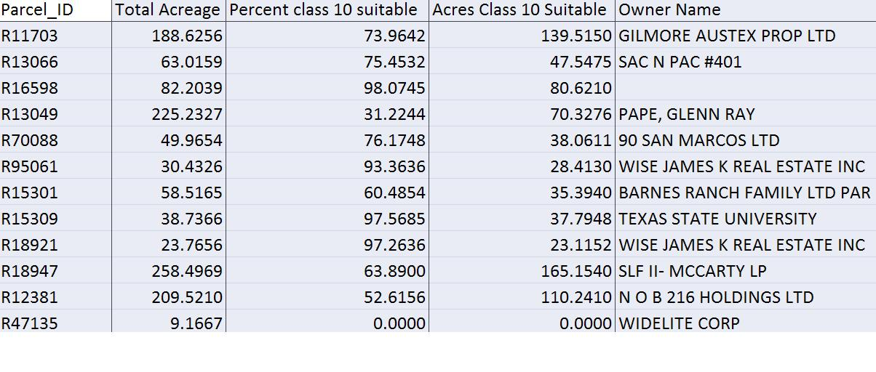
Based on the suitability table Parcel R16598 was chosen as the most suitable parcel. This parcel is 98 percent suitable containing 80.621 acres. The second most suitable parcel, R15309 is 97.56 percent suitable containing 37.79 acres. The third most suitable parcel, R18921 is 97.26 percent suitable containing 23.77 acres. Refer to the map titled “Suitable Parcels” on page 18 to see the selected parcels.
5.2 Micro Analysis Results
The Micro Analysis report offers detailed information about each parcel that concerns future development issues. This product includes a parcel map, detailed site analysis report, and digital photograph. The parcel map shows the outlined parcel of interest, 3 Phase electricity, Major Creeks, Water Lines, Major Roads and contour lines of 10 ft resolution. These features are mapped on top of a 2m resolution DOQQ image to further enhance the spatial relevance of the parcel. The detailed site analysis report goes into further detail about:
- Site location- address and ownership information.
- Access- outlines best site of access, distance to intestate from site of access, and distance to San Marcos Municipal Airport.
- Physical description- size of parcel in acreage, general land shape, what kind of clearing is necessary.
- Drainage- notes of any drainage features present on the parcel and or aquifer features.
- Planning and Zoning – current zoning, future zoning, and adjacent land uses.
- Electrical Power Supply – name of electric company.
- Water Supply- name of supplier.
- Sewer Supply- name of sewage agency.
- Police Protection- location of station.
- Fire Protection- first responder, location of station.
Concluding the results for the micro analysis section of the investigation is a digital photo taken from the selected sites. This offers a visual of land conditions and showing what type of clearing may be needed if any. The results of the micro analysis sections offer supplemental information to the selected parcels of the Macro Analysis suitability finding. In fact, the group felt that parcel R70088 was the best suitable parcel for development. It did not fall into the top three but after researching the site and ground checking our findings we decided that it would be our number one selection.
In summary the Macro Analysis results found suitable areas within the focus area of San Marcos Extra Territorial Jurisdiciton and city limit. Eleven parcels were selected using the suitability finding and an additional parcel was suggested by the city of San Marcos for development investigation. The results provided us with 12 suitable parcels for the most suitable large industrial or commercial businesses to be developed in the city. The Micro Analysis report offered detailed information about each parcel that concerns future development issues.

6.0 Discussion
6.1 Data quality
The majority of our data was of good quality, coming from reliable sources, although there were a few issues. The vacant parcel data from CAPCOG did not exist for the areas of the city’s ETJ outside Hays County. These parcels had to be manually inspected by our team to determine if they were actually vacant, which was done by using an aerial image of the area. However, this aerial image was only up to date as of 2005, so there was an issue of quality and accuracy between the aerial map and current parcel data for 2008. Site accuracy verification was performed for each parcel by cross referencing the vacancy classification of the “property assessment and tax information” provided by the Hays Central Appraisal District (HaysCad.com). Lastly, street data obtained from ESRI was limited, such as it not take into account whether streets were one-way or two-way, thus limiting our network analysis at the micro-level.
6.2 Data Processing
There are a few concerns that should be noted about our findings. For instance, the percentages that we attached to the infrastructure layers during the weighted overlay are the source of our results. If these percentages were to be altered according to different preferences then the results of the suitability map would be completely different. If we had more time to spend on this project we could give more than one result of the suitability map based on different weights.
Referring to the data quality discussed in 6.1, issues of data quality typically prolong the investigation with required checking. We had to double check the sites of the suitability map which should not be the case. The point of a suitability map is to know the areas that meet your criteria when in fact that may not be the case. It was evident that some of the properties that were located within the suitability map had been occupied since the vacant parcels inventory performed by CAPCOG in 2005. This is why it was important that we test our results through the Hays County Appraisal District to make sure that the property was in fact vacant.
In addition, a few of the parcels that we selected do indeed contain portions of the 100 year floodplain. However, these parcels are suitable because in all cases the floodplain does not cover the entire property parcel, and there are at least fifteen acres of suitable land in each parcel.
Lastly, each report for the Micro Analysis required a streets network to measure the network distance between the sites and features like the fire station, police station, . However, a current and detailed streets network is not readily available from the city or from any state data clearing house. Since we were under time constraints to finish the project, we used the ESRI national streets networks database. This database was not up to date because the frontage roads on I-35 were classified as two ways when in reality they are one way. Also there was a gap in the network on I-35 in Austin. This logical inconsistency on the network prevented us from measuring the distance from each site to the Austin Bergstrum International Airport. Instead we measure the distance to the San Marcos Municipal Airport.
6.3 Comprehensive Design
The initial thoughts and goals of our team focused creating a cohesive working environment that would transcend into the methodology and structure of the project. Before constructing the plan of action for the project, Central Texas Consulting established a Google mailing network (Gmail) between team members. This allowed for an organized digital work environment that offered easy file sharing and editing apart from the communication function offered by most email services. Our work was located on a network that could be accessed from any computer with internet capabilities. We logged out work in a Journal document that was shared between all team members. The synergy of the group was strong due to this resource.
The same principle applies to crafting the action plan for the project. Our goal was to arrive at a solution that could fit a real life situation. This steered us into the direction of creating the two stepped process of the Micro and Macro Analysis. We solved the problem through the Macro Analysis and performed the Micro Analysis to address relevant issues involved in the economic planning process.
6.4 Final Deliverables
So you might be wondering at this point what all that you may be getting. Listed and explained are the final deliverables for the project.
Detailed Final Report: This is what you are reading at the moment. The project proposal and progress repot will be included as well.
Individual Parcel Analysis Reports (11): ( Micro Analysis Results) Included in the report is a map, and detailed one page report, and a photograph for each parcel.
Professional Quality Poster: A poster was constructed and placed in the GIS hallway in Evan Liberal Arts Building. Feel free to print your copy. File is located on CD. Dimensions were set to 36 x 48 inches.
CD (2 copies) containing:
- Instructions on how to use the CD (Readme file): Have a better idea of where everything is located instead of guessing around.
- Poster File: Information that belongs on a WALL!
- All Data: A folder will be organized with the 5 shape files created from the project. Included within the data are pictures of each parcel. This picture folder contained hyperlinked images for data file 2 “choice_parcels”. You will notice the hyperlinks within the attribute table. Make sure the pathway is
- Metadata: Each of the five shapefiles includes their own metadata. Data Dictionary provided as well.
- Maps: All maps created for the projected will be on the CD
- Website: A hyper link will be located within the CD to access the project webpage.
- PowerPoint Presentation: All PowerPoint presentation created for the project will be available to view on the CD.

6.5 Pros/Cons of using GIS
Due to the highly spatial and geographical nature of selecting sites for future development, it was decided that using a GIS would be the best process for the work required in achieving our final results. The Texas State University contracted GIS software, ArcGIS , was used as it allowed our team to standardize and overlay what we deemed the most important criteria in site selection, giving us the type of comprehensive analysis that would likely be much more cumbersome to obtain via more traditional site selection methods. Within ArcGIS, tools such as buffers (Euclidian Straight Line Distance), raster calculator, overlay, and network analysis were used in order to obtain our results at both the macro and micro levels, which correspond to site selection and site analysis respectively.
The only limitation we encountered with the GIS was related to data quality. The condition of the data is a direct representation of the product being created. Many hours where put into formatting the attributes to work within the GIS. Otherwise, GIS offered us valuable tools to complete the project.

Appendix 1.0 Maps
Index Page
Map 1 Suitability Map and Criteria . . . . . . . . . . . . . . . . . . . . . . . . . . . . . . . . . . . . . . . . . . . 16
Map 2 Parcels Containing Suitability . . . . . . . . . . . . . . . . . . . . . . . . . . . . . . . . . . . . . . . . . 17
Map 3 Suitable Parcels . . . . . . . . . . . . . . . . . . . . . . . . . . . . . . . . . . . . . . . . . . . . . . . . . . . . . . . 18

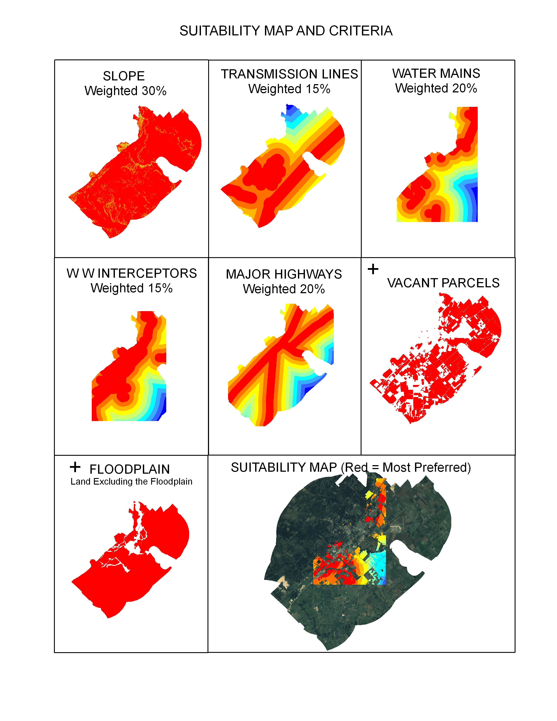

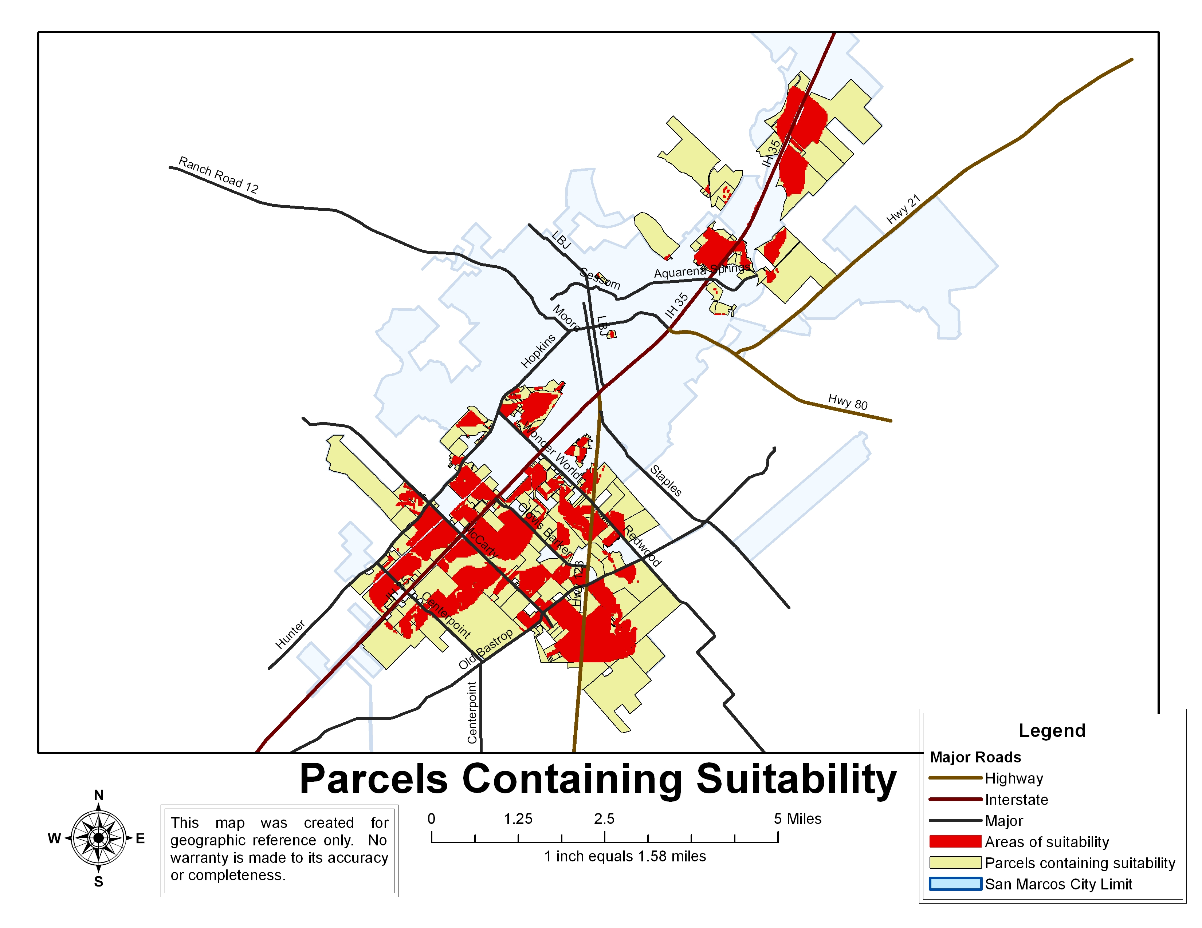
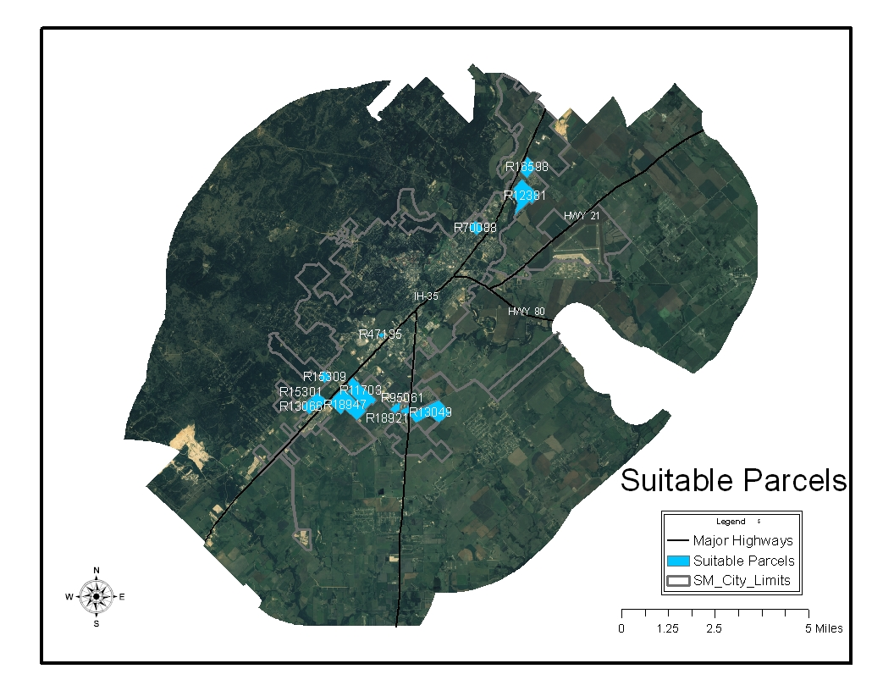
Appendix 2.0 Data Dictionary/ Metadata
Data Dictionary
Data file 1
File Name: 3_Phase_San_Marcos
Description: All three-phase electrical transmission lines in the city
Feature: Line
Scale: Scale of Source
Data Source: City of San Marcos, LCRA, PEC, BEC
Date Created: Nov. 2008
Comments: Combination of individually owned 3-phase lines from all 4 providers.

Data file 2
File Name: Choice_parcels
Description: The 12 final vacant parcels chosen as the most suitable.
Feature: Polygon
Scale: Scale of Source
Data Source: CAPCOG
Date Created: Nov. 2008
Comments: None

Data file 3
File Name: interestedparcels2
Description: All the most suitable vacant parcels based on scores from weighted overlay
Feature: Polygon
Scale: Scale of Source
Data Source: CAPCOG
Date Created: Nov. 2008
Comments: None

Data file 4
File Name: parcel_selection_Union2
Description: All vacant parcels within the city limits and ETJ of San Marcos
Feature: Polygon
Scale: Scale of Source
Data Source: CAPCOG
Date Created: Nov. 2008
Comments: Parcels outside Hays County were vacant based on a 2005 aerial photo.

Data file 5
File Name: suitability_map
Description: Vacant parcels with suitability scores resulting from weighted overlay
Feature: Polygon
Scale: Scale of Source
Data Source: CAPCOG
Date Created: Nov. 2008
Comments: The GRIDCODE attribute is the suitability score/level, with 10 being the best.

Data File 1: 3 Phase San Marcos

Keywords
Theme: three phase, transmission, electricity, San Marcos, power, lines, LCRA, Bluebonnet Electric, PEC

Description
Abstract
A layer displaying all three-phase electrical transmission lines in the city of San Marcos, Texas. The following providers are shown: LCRA, Pedernales Electricity, Bluebonnet Electric, and the City of San Marcos.

Purpose
This layer was created to provide a base to place a distance buffer, as the distance from three-phase transmission lines would be a factor included in the weighted overlay, of which the results can be seen on the layer entitled "suitability map".

Status of the data
In work
Data update frequency: As needed

Time period for which the data is relevant
Date and time: 11/2008 at time unknown
Description:
publication date

Publication Information
Who created the data: City of San Marcos, Tx
Date and time: 11/2008 at time: Unkown

Data storage and access information
File name: 3_Phase_San_Marcos
Type of data: vector digital data
Location of the data:
• \\GEO-305579\F\lines\3_Phase_San_Marcos.shp
Data processing environment: Microsoft Windows XP Version 5.1 (Build 2600) Service Pack 3; ESRI ArcCatalog 9.2.6.1500

Accessing the data
Size of the data: 0.303 MB
Data transfer size: 0.303 MB

Details about this document
Contents last updated: 20081205 at time 15482800
Who completed this document
Jeff Ivy
Texas State University
mailing address:
1610 N. IH-35 #915
San Marcos, Texas 78666
United States
(979) 248-0652 (voice)
ji1033@txstate.edu

Standards used to create this document
Standard name: FGDC Content Standards for Digital Geospatial Metadata
Standard version: FGDC-STD-001-1998
Time convention used in this document: local time
Metadata profiles defining additonal information
• ESRI Metadata Profile: http://www.esri.com/metadata/esriprof80.html
Horizontal coordinate system
Projected coordinate system name: NAD_1983_StatePlane_Texas_South_Central_FIPS_4204_Feet
Geographic coordinate system name: GCS_North_American_1983
Details
Map Projection Name: Lambert Conformal Conic
Standard Parallel: 28.383333
Standard Parallel: 30.283333
Longitude of Central Meridian: -99.000000
Latitude of Projection Origin: 27.833333
False Easting: 1968500.000000
False Northing: 13123333.333333

Planar Coordinate Information
Planar Distance Units: survey feet
Coordinate Encoding Method: coordinate pair
Coordinate Representation
Abscissa Resolution: 0.000000
Ordinate Resolution: 0.000000

Geodetic Model
Horizontal Datum Name: North American Datum of 1983
Ellipsoid Name: Geodetic Reference System 80
Semi-major Axis: 6378137.000000
Denominator of Flattening Ratio: 298.257222

Altitude System Definition
Resolution: 1.000000
Encoding Method: Explicit elevation coordinate included with horizontal coordinates

Bounding coordinates
Horizontal
In decimal degrees
West: -98.886490
East: -97.488040
North: 30.259755
South: 29.614265
In projected or local coordinates
Left: 2004562.764360
Right: 2445891.024201
Top: 14005642.230100
Bottom: 13773954.249625

Lineage
FGDC lineage
Process step 1
Process description: This shapefile was created by taking each provider's individual transmission line shapefile and using the Union tool to combine them into one shapefile/layer which would display. An attribute selection within the attribute table of this combined shapefile was used to create a new layer which would display only those lines that delivered three-phase power. The individual providers were as follows: LCRA, Bluebonnet Electric, PEC, and the City of San Marcos.
Source used: Server=geoffrey; Service=sde:oracle9i; User=gismgr; Version=SDE.DEFAULT
Process date: 20080905 at time 10305700

Who did this process
Joan Hickey
City of San Marcos
mailing and physical address:
630 E. Hopkins
San Marcos, Texas 78666
United States
JHickey@ci.san-marcos.tx.us

Spatial data description
Vector data information
ESRI description
3_Phase_San_Marcos
ESRI feature type: Simple
Geometry type: Polyline
Topology: FALSE
Feature count: 2283
Spatial Index: TRUE
Linear referencing: FALSE

SDTS description
Feature class: SDTS feature type, feature count
• 3_Phase_San_Marcos: String, 2283

Data File 2: Choice Parcels

Keywords
Theme: Parcel, Land, Suitable, Economic, Development, Map, Commercial, Industrial

Description
Abstract
A shapefile displaying the twelve final parcels selected as the most suitable for commercial or industrial development in the city of San Marcos, Texas.

Purpose
This shapefile was created as part of a project for the GEO 4427 class at Texas State University, involving the identification of parcels of land suitable for commercial and industrial development.
Status of the data
In work
Data update frequency: As needed

Time period for which the data is relevant
Date and time: 11/2008 at time unknown
Description:
publication date
Publication Information
Who created the data: City of San Marcos
Date and time: 11/2008 at time Unknown

Data storage and access information
File name: Choice_parcels
Type of data: vector digital data
Location of the data:
• \\GEO-305579\F\11_17\Choice_parcels.shp
Data processing environment: Microsoft Windows XP Version 5.1 (Build 2600) Service Pack 3; ESRI ArcCatalog 9.2.6.1500
Accessing the data
Size of the data: 0.004 MB
Data transfer size: 0.004 MB

Details about this document
Contents last updated: 20081205 at time 16053900

Who completed this document
Jeff Ivy
Texas State University
mailing address:
1610 N. IH-35 #915
San Marcos, Texas 78666
United States
(979) 248-0652 (voice)
ji1033@txstate.edu

Lineage
FGDC lineage
Process step 1
Process description: This shapefile began with the layer entitled "interestedparcels1", which displayed all parcels that were given a value of 10 resulting from the weighted overlay described in the process section of the metadata for the "suitability map.shp" layer. From this base layer, we did further anaylsis, including site-level anylsis involving visting parcels in person, to narrow our selection down to a minimum of 10 parcels we considered to be most suitable for commercial or industrial development. After this proccess of narrowing down the most suitable parcels, the twelve parcels seen in this shapefile was the result.
Source used: Server=geoffrey; Service=sde:oracle9i; User=gismgr; Version=SDE.DEFAULT
Who did this process
Joan Hickey
City of San Marcos
mailing and physical address:
630 E. Hopkins
San Marcos, Texas 78666
United States
(512) 393-8237 (voice)
JHickey@ci.san-marcos.tx.us
Spatial data description
Vector data information
ESRI description
Choice_parcels
ESRI feature type: Simple
Geometry type: Polygon
Topology: FALSE
Feature count: 12
Spatial Index: TRUE
Linear referencing: FALSE

SDTS description
Feature class: SDTS feature type, feature count
• Choice_parcels: G-polygon, 12

Data File 3: InterestedParcels1

Keywords
Theme: suitable, parcels, commercial, industrial, development, economic

Description
Abstract
A map displaying selected parcels taken from a suitability map of parcels of land suitable for commercial and industrial development. The parcels displayed are those which had values indicating they were "most suitable".

Purpose
This shapefile was created as part of a project for the GEO 4427 class at Texas State University, involving the identification of 10 parcels of land most suitable for commercial or industrial development.

Status of the data
In work
Data update frequency: As needed

Time period for which the data is relevant
Date and time: 11/2008 at time unknown
Description:
publication date
Publication Information
Who created the data: City of San Marcos
Date and time: 11/2008 at time Unknown

Data storage and access information
File name: interestedparcels1
Type of data: vector digital data
Location of the data:
• \\GEO-305579\F\11_17_08\interestedparcels1.shp
Data processing environment: Microsoft Windows XP Version 5.1 (Build 2600) Service Pack 3; ESRI ArcCatalog 9.2.6.1500
Accessing the data
Size of the data: 0.152 MB
Data transfer size: 0.152 MB

Details about this document
Contents last updated: 20081205 at time 15540000
Who completed this document
Jeff Ivy
Texas State University
mailing address:
1610 N. IH-35 #915
San Marcos, Texas 78666
United States
(979) 248-0652 (voice)
ji1033@txstate.edu

Lineage
FGDC lineage
Process step 1
Process description: This layer was created by selecting by attribute all parcels that had a value of 10 from the layer titled "suitability _map". A value of 10 corresponded to parcels most suitable for the desired development. This value resulted from the weighted overlay described for the layer "suitability_map".
Source used: Server=geoffrey; Service=sde:oracle9i; User=gismgr; Version=SDE.DEFAULT
Process date: 11/2008 at time N/A
Who did this process
Joan Hickey
City of San Marcos
mailing and physical address:
630 E. Hopkins
San Marcos, Texas 78666
United States(512) 393-8237 (voice)
JHickey@ci.san-marcos.tx.us

Spatial data description
Vector data information
ESRI description
interestedparcels1
ESRI feature type: Simple
Geometry type: Polygon
Topology: FALSE
Feature count: 575
Spatial Index: TRUE
Linear referencing: FALSE

SDTS description
Feature class: SDTS feature type, feature count
• interestedparcels1: G-polygon, 575

Data File 4: Parcel_Selection_Union2

Keywords
Theme: San Marcos, vacant parcels, land, vacant

Description
Abstract
A map displaying all vacant parcels of land in the city of San Marcos, Texas.

Purpose
This shapefile was created as part of a project for the GEO 4427 class at Texas State University, involving the identification of parcels of land suitable for commercial and industrial development. This particular map was intended to give a layer with only vacant parcels of land, and give a base to create a binary raster map from.

Status of the data
In work
Data update frequency: As needed

Time period for which the data is relevant
Date and time: 11/2008
Description:
publication date
Publication Information
Who created the data: City of San Marcos, Texas
Date and time: 11/2008

Data storage and access information
File name: parcel_selection_Union2
Type of data: vector digital data
Location of the data:
• \\GEO-305579\F\11_17_08\parcel_selection_Union2.shp
Data processing environment: Microsoft Windows XP Version 5.1 (Build 2600) Service Pack 3; ESRI ArcCatalog 9.2.6.1500

Accessing the data
Size of the data: 0.797 MB
Data transfer size: 0.797 MB

Details about this document
Contents last updated: 20081205 at time 15574200
Who completed this document
Jeff Ivy
Texas State University
mailing address:
1610 N. IH35 #915
San Marcos, Texas 78666
United States
(979) 248-0652 (voice)
ji1033@txstate.edu

Lineage
FGDC lineage
Process step 1
Process description: After identifying vacant parcels manually by using an aerial map of the city from 2005, this layer was created following a selection of all vacant parcels from the general map of all parcels in the city.
Source used: Server=geoffrey; Service=sde:oracle9i; User=gismgr; Version=SDE.DEFAULT

Who did this process
Joan Hickey
City of San Marcos
mailing and physical address:
630 E. Hopkins
San Marcos, Texas 78666
United States
(512) 393-8237 (voice)
JHickey@ci.san-marcos.tx.us

Spatial data description
Vector data information
ESRI description
parcel_selection_Union2
ESRI feature type: Simple
Geometry type: Polygon
Topology: FALSE
Feature count: 3060
Spatial Index: TRUE
Linear referencing: FALSE

SDTS description
Feature class: SDTS feature type, feature count
• parcel_selection_Union2: G-polygon, 3060

Data File 5: Suitability Map

Keywords
Theme: vacant parcels, commercial, industrial, development, economic, land, suitable, map

Description
Abstract
A map showing the results of a weighted overlay, displaying parcels of vacant land in San Marcos, Texas that would be most suitable for commercial or industrial development. Factors in the overlay that were weighted included the distance from highways/I-35, as well as the distance from existing infrastructure (sewer/water, electricity, etc).

Purpose
This shapefile was created as part of a project for the GEO 4427 class at Texas State University, involving the identification of parcels of land suitable for commercial and industrial development.

Status of the data
In work
Data update frequency: As needed

Time period for which the data is relevant
Date and time: 11/2008
Description:
publication date
Publication Information
Who created the data: City of San Marcos
Date and time: 11/2008 at time Unknown

Data storage and access information
File name: suitability_map
Type of data: vector digital data
Location of the data:
• \\GEO-305579\F\11_17_08\suitability_map.shp
Data processing environment: Microsoft Windows XP Version 5.1 (Build 2600) Service Pack 3; ESRI ArcCatalog 9.2.6.1500
Accessing the data
Size of the data: 0.352 MB
Data transfer size: 0.352 MB

Details about this document
Contents last updated: 20081205 at time 16012100
Who completed this document
Jeff Ivy
Texas State University
mailing address:
1610 N. IH-35 #915
San Marcos, Texas 78666
(979) 248-0652 (voice)
ji1033@txstate.edu

Process step 1
Process description: Using data provided by the city of San Marcos, straight line distance buffers were created around water mains, sewage/wastewater lines, as well as around Interstate 35 and local highways 80 and 123.Using electrical transmission line data obtained from Pedernales Electric, Bluebonnet Electric, the LCRA, and the city of San Marcos, a straight line distance buffer was created around all 3-phase transmission lines for every provider. Each provider’s individual transmission layer was combined with those of other providers, creating one single combined transmission line layer, which the distance buffer was placed around. Binary raster layers were created to remove any non-vacant parcels, as well as any parcels in the floodplain (e.g. 1 = vacant parcel while 0 = non-vacant parcel). The raster calculation from which the suitability map was derived is as follows: ([reclass_water] * .20) + ([reclass_ww_in] * .15) + ([reclass_tln] * .15) + ([reclass_hwy] * .20) + ([slope_reclass] * .30) [recl_vacant] + [reclass_fldpln] CON([Calculation4] == 20, [Calculation3], 0) INT ([Calculation5])
Process software and version: ArcGIS 9.2
Source used: J:\11_05\suit_10_11_10
Process date: 11/2008

Spatial data description
Vector data information
ESRI description
suitability_map
ESRI feature type: Simple
Geometry type: Polygon
Topology: FALSE
Feature count: 899
Spatial Index: TRUE
Linear referencing: FALSE

SDTS description
Feature class: SDTS feature type, feature count
• suitability_map: G-polygon, 899

Appendix 3.0 Contribution of Each Team Member
  - Philip Ramirez -Project Manager
  - Proposal
Publishing/Editing
Formatting
Timeline
  - Progress Report
Publishing/Editing
Formatting
PowerPoint
  - Final Report
Literature Review
Discussion
Publishing/Editing
Formatting
  - GIS analysis/work
Micro Analysis Organization and Formatting
Micro Analysis Parcel Maps (11)
“Parcels Containing Suitability” Map
Poster
  - Paul Daugherty – Assistant Manager
  - Proposal
Collected Data
Process and Modify Data
Methodology
Interviewed Sources
  - Progress Report
“Work Completed”
Creation of Maps
  - Final Report
Methodology/Procedures
  - GIS analysis/work
Macro Analysis data processing/overlay
Micro Analysis Reports data collection
Network Analysis
Picture GIS Hyperlinks
Data collection and organization
  - Jared Reid – GIS analysis/ Web Master
  - Proposal
Budget
Reference Data
Logo
  - Progress Report
“Work to be completed”
Creation of Maps
  - Final Report
Results
  - GIS analysis/work
Web Design
Manifold
Google Group Networking
Parcel Photography
PowerPoint
  - Jeff Ivy- GIS Analysis
  - Proposal
Introduction
Implications
Final Deliverables
Conclusion
PowerPoint
  - Progress Report
Introduction
Scope/Purpose
Project Appraisal
PowerPoint
  - Final Report
Introduction
Data
Appendix: Metadata, Data Dictionary
  - GIS analysis/work
Metadata
Data Dictionary
Micro Analysis Processing

